Guidelines for submitting your abstract in IMA-2019 platform

Fill your email and submit in order to receive a Verification code in your email account.
In the next step fill the Verification code in the form to proceed to the Abstract submission form.
Add (or modify) your information including name, phone, address and click submit.
Follow instructions and fill the Topic menu (Dropdown list), the Title (capital letters) and copy your abstract text in the Summary form. Indicate in the Comments form your preference for Oral Presentation, Poster Presentation or Invited. Add figures (if any) by uploading them in the File/Image form.
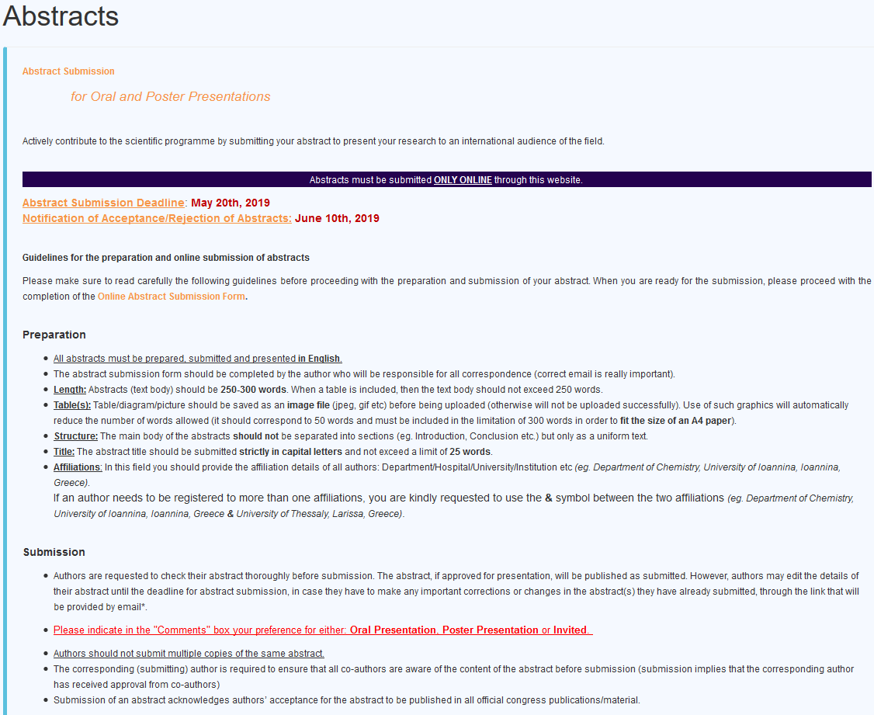

Proceed by adding the authors’ names and affiliations indicating the display order and the presenter.
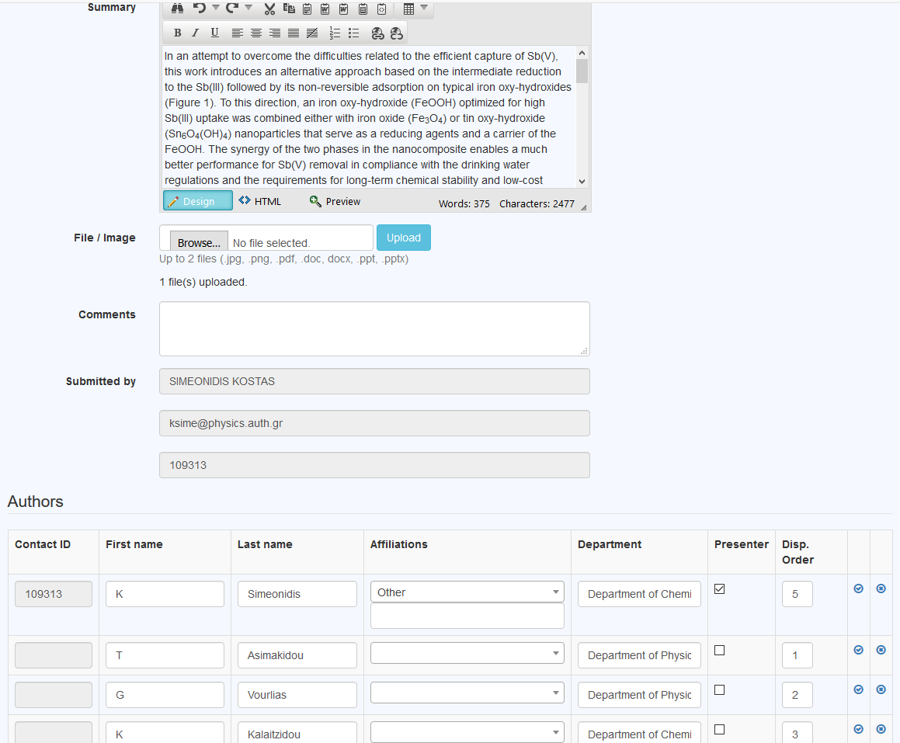

If everything goes well you will get the following message and a confirmation email to your account.

